Insert School Logo Here
THE EMERGENCY PROCEDURES AND RISK MANAGEMENT PLAN HANDBOOK
School’s Address
School’s Phone Number
School’s Email
School’s Website
Director’s Name
Owner’s Name

Table of Content
- Foreword
- Communication in Emergency
- Physical Environment and Safety Measures
- Child Abuse and Neglect Policies
- Fire and Tornado Drill Procedures
- Emergency Procedures
- Emergency Evacuation Procedures
- Emergency Evacuation Plan
- Lockdown Plan
- Fatal and Multiple Injuries Emergency
- Fire Emergency
- First Aid
- Gas Leaks
- Inclement Weather
- Medical Emergency Procedures
- Missing or Abducted Child Procedure
- Power Outages
- Phone Threats
- Written Threats
- Insurance Coverage
- Accident Insurance
- Liability Insurance
- Non-owned auto insurance
- Safety and Health
- Arrival
- Departure
- Disease Control
- Handwashing
- Cleaning Blood or Body Fluid Spills
- Toy Cleaning
- Other Policies
8. Food Safety
a. General
b. Kitchen Equipment
c. Utensils/cleaning and storage
d. Food
9. Illness
10. Indoor Safety
- General Indoor Safety Measures
- Heating/Cooling System
- Floors
- Windows and Doors
- Washrooms
- Sleeping Accommodations
11. Outdoor Safety
12. Furniture, Equipment, and Toys
13. Pet Handling
14. Poison Control
15. Administering Medication
16. Safety and Health Inspections
17. Record Keeping
- Record keeping policies
b. Records related to children
c. Staff records
d. Records related to running of the daycare
e. Fire safety records
f. Hygiene records
18. Transportation Policies
- General Transportation Policies
- Vehicle Requirements
19. Appendices
- Emergency Kit List
- First Aid Kit Lists
- Emergency Numbers
- List of Staff Responsibilities in Emergency Situations

FORDWARD

This emergency plan describes the procedures that will be used by INSERT SCHOOL NAME to provide for the care and the well-being of the children under our care and our staff. This plan is meant to address any situation that may put the school in harm and threaten lives. This plan provides the school’s policies and procedures that are followed by the staff on a daily basis.

Communication in Emergency

Communication with Parents
- INSERT SCHOOL NAME’s will keep emergency contact information for each child easily accessible. The contact information that is included is home and work numbers, e-mail addresses, cell phone numbers for parents and others who are authorized contacts.
- INSERT SCHOOL NAME will have alternative contact numbers for someone within the family’s network to be contacted with notification that the child or employee is safe.
- The staff members placing the calls will have a clear plan on what info will be given to the families when making calls in emergency situations.
- The Director will confirm all parents and emergency contacts have be reached out to and spoken with.
- Staff members must report back to administration with updates, needs, and problems that may have occurred when talking with the parents, guardians or emergency alternative contacts.
- INSERT SCHOOL NAME will use the local radio and TV stations as communication methods for emergency situations.

Communication within our Organization
- A list of staff members responsible for calling 9-1-1, utility companies and parents will be composed. All employees will have access to the emergency list to contact for each child and employee.
- During an emergency the Director or the designated staff member will call 911.
- The person calling 911 will remain calm and answer the dispatcher’s questions.
- The person calling 911 will remain on the phone with the dispatcher until they are confirmed they can hang-up.
- Important emergency numbers (electric, gas, water, poison control) will be posted in areas throughout the school for all to have access too easily.

Physical Environment and Safety Measures
- Lead free paint is used on all painted surfaces included painted furniture and equipment.
- Electrical outlets accessible to children will have protective coverings.
- No extensions cords will be used in areas accessible to children. Extension cords not in use will be unplugged.
- Walls and flooring are washable and free of lead-based paint.
- All floors will be kept free from cracks and finished so that they can be cleaned easily, properly, and efficiently.
- Floors will be kept clean, in a non-slippery condition, and free from tripping hazards, including throw and or rugs.
- All areas of the facility are lighted to meet the correct levels of illumination required by our governing bodies.
- Adjustable shades are provided for protection from glare and to promote an atmosphere conducive to sleep at nighttime.
- Strings and cords for the shades will be cordless or strings will be less than 5 feet long.

Child Abuse and Neglect Policies

General Child Abuse Policies
- All INSERT SCHOOL NAME employees will be screened by the appropriate law enforcement agency using the INSERT states background system.
- Adults will never be alone with children on premises unless they can be observed by others. Example - rooms cannot have blinds down to block views of students with one adult, during the day.
- All staff or volunteers ARE NOT EVER physically, verbally, or emotionally abuse or punish children.

Reporting Suspected Child Abuse and Neglect
- At the first reasonable cause to believe that child abuse exists, the reporting adult will immediately inform the Director who will determine the action to take.
- An immediate phone call to the local law enforcement will be made by the reporting adult.
- A written report, as a backup to the phone report, will be completed and filed with the director or owner.

Fire/Tornado Drill Procedures

Fire Drill
Fire drill will be practiced at random times of the day. The drills will occur one to two times a month. at least once a month. Evacuations maps are posted throughout the school and easy to access and see at all times. All employees and students will be prepared for the drills, and review what happens during a drill often so that all are prepared! It is important that all remain calm and keep their heads during any emergency drill!
- The director or owner will inform the staff in advance that a drill will occur later in the week.
- The staff will talk to their students about the alarm, rules and procedures to take while evacuating the building.
- The director or owner will sound the alarm, and the school will take action and do the evacuation procedure.
- Children will proceed immediately to their designated outside school meeting spot.
- If possible, one staff member should try to grab the attendance sheets, emergency contact list, and cell phones with them.
- The staff will take attendance of the students and check off their attendance sheets or communication app.
- If safe, the director or owner will quickly check hiding spaces in the school for any lost children. They will also check for any sources of smoke or fire during a real emergency fire situation.
- The director or owner will then meet the rest of the students and employees at the designated area.
- The director or owner will review attendance by checking the sign in and out sheets, or other documentation for student’s attendance (the school’s communication app).
- The director or owner will time the drill to see how long it took to evacuate the building.
- The director or owner will confirm with local law officials when it is safe to return to the building. The director or owner will assist with children who need support to return to the building like children of the younger ages.
- The director or owner will complete the first drill log with the following information: date and time of the drill, number of students, number of teachers, and the length of time it took for the students and teachers to evacuate the building.
- Parents will be notified a fire drill occurred on this day.

Tornado Drill
Tornado drills will occur twice a year, at most times during the spring and summer as tornados occur during the warmer months. Evacuations maps are posted throughout the school and easy to access and see at all times. All INSERT SCHOOL NAME employees and students will be prepared for the drills, and review what happens during a drill often so that all are prepared! It is important that all remain calm and keep their heads during any emergency drill!
- The director or owner will inform the staff in advance that a drill will occur later in the week.
- The staff will talk to their students about the alarm, rules and procedures to take during shelter in place.
- The director or owner will sound the alarm, and the school will take action and do the shelter in place/lockdown procedure.
- Children will proceed immediately to the designated lockdown site/shelter in place designated spot.
- If possible, one staff member should try to grab the attendance sheets, emergency contact list, and cell phones with them.
- Students will take the safety position by kneeling on their knees and elbows with their foreheads on the floor and covering their heads with their hands.
- The staff will take attendance of the students and check off their attendance sheets or communication app while also comforting students to take the proper safety position.
- If safe, the director or owner will quickly check hiding spaces in the school for any lost children.
- The director or owner will meet at the shelter in place designated spot to review attendance by checking the sign in and out sheets, or other documentation for student’s attendance (the school’s communication app).
- The director or owner will time the drill to see how long it took for the students to take shelter.
- The director or owner will confirm when it is safe to leave the shelter in place designated spot. The director or owner will assist with children who need support to enter back into the program main area.
- The director or owner will complete the first drill log with the following information: date and time of the drill, number of students, number of teachers, and the length of time it took for the students and teachers to evacuate the building.
- Parents will be notified a drill occurred on this day.

Emergency Procedures

General Emergency Evacuation Information
Procedures are in place in the event of an emergency. These are clearly written procedures to ensure the safety of the children and staff. All employees upon hire will be trained and skilled in any emergency evacuation procedure the school has in place.
- All Employees of INSERT SCHOOL NAME are responsible for the safety of the children. The school staff will listen and coordinate with public safety officials in deciding what action is best to take during an emergency procedure.
- INTSERT SCHOOL NAME personnel will have a detailed orientation and intensive training in their responsibilities within the plan.
- Emergency phone numbers and evacuation plans are posted throughout the school.
- Monthly drills are to be conducted to ensure all employees are current with what emergency policies and procedures are in place.
- Reasons for evacuation include but are not limited to:
- Toxic Fumes/Gas Leaks
- Power Outage
- Tornado
- Fire
- Severe Snow- or Thunderstorm
- Lockdown/Intruder Alert
- Reasons for shelter in place/lock down include but are not limited to:
- Active Shooter
- Tornado
- Riots
- Hostage Situation

Emergency Evacuation Procedure
- Evacuate everyone as quickly and calmly as possible.
- The Director/owner of the school will check all potential hidden areas where someone may be.
- Evacuate through the nearest exit to a safe spot away from the school.
- If it is safe to do so, and it can be done quickly, young toddlers can be put in strollers or cribs in order to move them safely to the designated outside area.
- Upon arriving to the designated evacuation designated area, attendance must be taken of all children and signed off on the sign in and out attendance sheet or verified by the use of the school’s communication app.
- The Director, owner or appointed teacher will call local authorities from a cell phone once the evacuation is complete.
- Director, owner or appointed teacher will provide first aid if needed.
- Parents may be called upon to pick up their children from the designated safe area.

INSERT SCHOOL’S NAME DESIGNATED EVACUATION SITE IS:

Lockdowns
During an emergency a situation that may cause harm to a person inside the school, such as hostage, active shooter, intruder, or other disturbances a lockdown procedure will occur.
- The building director or designee will announce that there is a lockdown situation. This will occur (INSERT WHAT SYSTEM WILL BE USED TO NOTIFY THE SCHOOL)
- During a lockdown situation, all children are kept away from danger at their specific classrooms designated lockdown site.
- Staff members are responsible for taking attendance and ensuring all students remain in the designated lockdown site.
- Staff members must also ensure that no unauthorized individuals leave or enter the building.
- Staff and children remain in their designated lockdown site, locking the door if possible, turning off the lights, closing the windows.
- Staff members must encourage students to remain quiet and still in their lockdown placement.

INSERT SCHOOL’S NAME DESIGNATED LOCKDOWN SITE IS:

Fatal and/or Multiple Injury Emergency
- In a situation that a fatality occurs, weapons or equipment involved will not be moved or touched. The only exception of this is to prevent further accidents/injuries. The weapons or equipment can only be touched by local law authorities.
- In any case of fatality, the director or owner will immediately provide an oral report to local authorities. A written report will also be completed within 8 hours of the situation. The report will include a complete description of the circumstances, the number of fatalities, if any, and the extent of the injuries.
Fire Emergency
- The first person to smell or see fire or smoke will pull the fire alarm.
- The alarm will sound, and the teachers will assist their students quickly to evacuate the building.
- Children will proceed immediately to their designated outside school meeting spot.
- If possible, one staff member should try to grab the attendance sheets, emergency contact list, and cell phones with them.
- The staff will take attendance of the students and check off their attendance sheets or communication app.
- If safe, the director or owner will quickly check hiding spaces in the school for any lost children. They will also check for any sources of smoke or fire during a real emergency fire situation.
- The director or owner will then meet the rest of the students and employees at the designated area.
- The director or owner will review attendance by checking the sign in and out sheets, or other documentation for student’s attendance (the school’s communication app).
- The director or owner will confirm when it is safe to return to the building by getting approval by the local law official. The director or owner will assist with children who need support to return to the building like children of the younger ages.
- Parents will be notified once all is calm and safe.

First Aid
- All INSERT SCHOOL NAME employees hold a valid first-aid and CPR certificate. Copies of the certificates are located in each staff members file.
- Every room in the school has a complete first-aid kits for easy use and access. First aid kits will be checked and restocked each month.
- Established first aid procedures are to be used in case of a medical emergency.
- No medications of any kind may be administered without authorization of a licensed physician. In specific circumstances, the school has a medication administering policy for giving medication to a child. In administering the prescription medication to a child, the authorized adult:
- Will only accept prescribed medication from the parent if it is in the original container labeled with the child's name, date prescription was filled, expiration date, and legible instructions for administration.
- Will only give prescription medication as authorized in writing from the child’s doctor.
- Will ensure the medication is stored safely.
- Will record on a medication administered log

Gas leaks or Toxic fumes
- If gas or toxic odor is detected, evacuation procedure will occur immediately.
- If it is possible and clear of where the gas leak is originating from, a staff member may shut the valve off.
- The staff will take the following items, if possible:
- First Aid Kit
- Attendance sheets/iPad for App access
- Children’s emergency and medical information forms
- Cell phone
- Children will be moved to the outside designated area.
- Director/owner will call INSERT GAS COMPANY police and fire departments from the designated outside spot.
- Director/owner will call or email to notify parents when it is safe to do so.

Inclement Weather
Staff will monitor all inclement weather situations. Staff will also ensure battery powered radios, flashlight, emergency lighting, power, hear and cell phones are in working condition.
- Teachers are notified of the inclement weather situation and are provided any details that may be important.
- The teacher’s guide the students to the designated lockdown site.
- If safe to do so, one teacher should try to grab their cell phones, the attendance sheets and the first aid kit.
- Students will take the safety position by kneeling on their knees and elbows with their foreheads on the floor and covering their heads with their hands.
- The staff will take attendance of the students and check off their attendance sheets or communication app while also comforting students to take the proper safety position.
- If first aid is needed, it will be administered to the student who is harmed, while the others resume the safety position.
- If safe, the director or owner will quickly check hiding spaces in the school for any lost children.
- The director or owner will meet at the shelter in place designated spot to review attendance by checking the sign in and out sheets, or other documentation for student’s attendance (the school’s communication app).
- The director or owner will confirm with local law authorities and/or review the broadcast of the weather to verify when it is safe to leave the shelter in place/lockdown designated spot.
- Staff needs to walk through the facility looking for any damage created by the inclement weather, such as fire, water, or structural damage.
- Parents will be notified when it is safe to pick up their child.

Tornado
- At the moment when the director, owner or another teacher receives a tornado warning or if a tornado sighting is reported, children and staff members should seek shelter WITHIN the building at their designated lockdown/shelter in place site.
- If possible, one staff member should try to grab the attendance sheets, emergency contact list, and cell phones with them.
- Students will take the safety position by kneeling on their knees and elbows with their foreheads on the floor and covering their heads with their hands.
- The staff will take attendance of the students and check off their attendance sheets or communication app while also comforting students to take the proper safety position.
- If safe, the director or owner will quickly check hiding spaces in the school for any lost children.
- The director or owner will meet at the shelter in place designated spot to review attendance by checking the sign in and out sheets, or other documentation for student’s attendance (the school’s communication app).
- The director or owner will confirm with local law authorities when it is safe to leave the shelter in place/lockdown designated spot. The director or owner will assist with children who need support to enter back into the program main area.

Severe Thunderstorm
- The facility will be evaluated for its ability to withstand high winds.
- The best internal protective areas within the facility are identified as follows: office, bathrooms, and storage rooms.
- The staff will monitor local radio and TV stations for public warnings when weather conditions indicate the signs.
- All staff members and children must know the "symptoms" of severe thunderstorms and tornadoes.
- During a severe thunderstorm warning, or during periods of particularly high winds, children will be kept away from glass

Winter Storm
The dangers of winter storms are can cause safety concerns. These include but are not limited to, intense cold, snow, ice, breakdown of transportation due to road conditions and disruption of electrical power.
- The local radio/TV will be watched to help monitor for snow, ice, and winter weather warnings.
- The school will be prepared to change hours of operations for parents and allocate a safe pick-up time.
- The school will conserve utilities and be conscious to keep children warm and comfortable.

Medical Emergency

If a child or a staff member receives an injury while at school, an accident report is completed. The report includes information regarding the time and date of the injury, what happened, how it was treated, and a signature of the witnessing teacher. This report is provided to parents before the child leaves the center and is also recorded in the center's medical logbook.
- In case of a minor injury such as bump, scrape or small cut, staff members are limited to treatment using ice, washing injured area with soap and lukewarm water, applying a bandage, and giving a hug.
- In case of a serious or life-threatening injury, staff members will follow established First Aid emergency procedures and parent(s) will be contacted as soon as possible. If hospitalization is required, the child will be taken by emergency personnel to the nearest emergency room.
- A teacher from the center will accompany the ill or injured child to the hospital and will stay until a parent or an authorized person arrives.

Missing or Abducted Child Response
If a child is not accounted for at any time, the staff member responsible for the child should:
- Search the premises for the missing child. Each area that a child could potentially hide should be searched, as well as the outdoor areas of the facility.
- The staff member should also double-check to confirm the location of the child by checking the sign-in and sign-out log.
- If the child is not located after all potential hiding spots and immediate outdoor areas have been searched, the facility director should be notified that the child is missing.
- Begin Lock Down procedure. All exits must be monitored by employees letting no one in or out of the facility.
- The staff member responsible for the child will call 911, since he/she will have the best knowledge of what the child was wearing that day, along with other distinctive features.
- The facility director will notify the guardians of the child that the child is missing from the facility.
- While the police are in route to the facility, the staff will continue to search the facility for the missing child. The staff should look in every cabinet, closet, cubby, and every other location where a child may hide.
- The facility director will stay on the facility premises at all times to be the contact person for the police department, as well as the missing child’s guardians.
- The police should be asked to activate Amber Alert by the facility director.

Power Outage Emergency
- Program Director or designee will try to identify the problem
- Director will call 9-1-1 if concerned about a fire or safety hazard
- Staff will unplug all electrical equipment; turn off all but one light
- Director will contact the property manager, if needed
- Director will contact INSERT ELECTRIC INFO
- All parents will be notified if power outage is prolonged
- If there is a danger of fire, evacuate the facility.
- If an electrical shortage is suspected, turn off power at the main control point.

Telephone Threat
The staff member taking the call should notify the Director that a bomb threat is in progress so that:
- The building may be evacuated immediately.
- The facility director or designee will contact local law enforcement via 911.
- The staff member talking to the caller should keep the caller on the line as long as possible.
- Information should be recorded as quickly and accurately as possible. The following information should be noted.
- The time the call was received
- The caller’s exact words
- A description of the caller’s voice
- Where is the bomb located?
- When is the bomb set to go off?

Written Threat
The staff member that receives the written threat should handle the letter as little as possible and should save all materials that were contained in the letter.
- All materials involved in the threat should be turned over to local law enforcement authorities.
- The facility director or designee should be immediately notified of the letter.
- Local law enforcement should be contacted by calling 911.
- The building should be evacuated until it is determined that there is no longer any danger.

Insurance Coverage

Accident Insurance
- Children enrolled in the INSERT SCHOOL NAME program are covered by the accident policy as part of their enrollment. The enrolled child is covered during the regular activities for the class in which the child is enrolled.
- Staff members are covered against work related accidents by the Worker’s Compensation insurance policy.

Liability Insurance
- INSERT SCHOOL NAME maintains General Liability Insurance to protect the facility, the employees, and the parents against suit for negligent acts in the performance of their duties for INSERT SCHOOL NAME.

Non-owned auto insurance
- The co-op does not provide auto insurance for any individual. Drivers for INSERT SCHOOL NAME fieldtrips will provide evidence of their own automobile insurance.
- The following licensed daycare transportation company will be used to transport children for Field Trips: INSERT BUS INFO!

Safety and Health

Arrival
- Upon arrival, a parent shall escort the child into the classroom being certain that at least one teacher is present before leaving.
- Each attending child must be signed in on the daily attendance log.
- Attendance logs must be kept at the preschool for one year.
Departure
Departures must also be recorded on the attendance log. When leaving, a parent must notify the teacher of the departure and must escort child(ren) out of the building.
- At least two staff members must remain at the center until all children have left.
- The center must have a list of all persons regularly authorized to take a child from the center on file.
- In the event a child is to be taken from the center by those not on the list, the parent/guardian must send a written consent form authorizing the release of the child.
- Parents/guardians shall also notify the person who takes the child that picture identification will be required. The teachers and assistants must check the photo identification before releasing the child into the care of that person.
- The school assumes no responsibility for unescorted any child on the premises after the child has been signed-out from the attendance log.
- Under no circumstances will a child be released without prior authorization.

Disease Control

- Handwashing
- Washing hands thoroughly is often critical to preventing the spread of illnesses.
- Liquid soap and running water shall be used. Water temperature should be between 85- and 120-degrees F. The temperature should never exceed 120 degrees F. to prevent scalding. Hands must be washed for at least 20 seconds.
- Hand washing steps will be posted in all washrooms, kitchen and sinks.
- Wet hands
- Apply liquid soap
- Wash – make bubbles for at least 10 sec
- Dry with individual washcloth or air blower
- There are many times throughout the day when children and adults must wash their hands:
- Immediately upon arrival
- After:
- using the restroom
- helping a child with toileting/diapering
- sneezing, coughing, or wiping a runny nose
- playing outside
- cleaning or using chemicals
- giving medication
- contact with blood or body fluids
- touching animals or cleaning their environments
- assisting a sick child
- taking out the garbage

- Before:
- preparing or serving food
- eating
- setting the table
- giving medications
- touching eyes, nose, or mouth
- administrating first aid (if possible)
- putting on protective gloves

- Cleaning Blood
Staff will follow universal precautions when exposed to blood and blood-containing body fluids:
- Whenever blood and body fluids are present latex rubber gloves should be used to minimize exposure of the attending person while the injury is cleansed and/or dressed.
- Soiled clothes of the injured child must be bagged to be sent home.
- Place waste in a plastic bag for disposal.
- Thoroughly wash hands with soap.
- Whenever cleaning and disinfecting environmental surfaces in which blood and body fluids are present, utility latex gloves should be placed between the blood and the attending person.
- Use disposable paper towels or other disposable materials to remove blood and body fluids.
- Disinfect the affected area(s) and cleaning tools with a disinfectant cleaning solution or bleach solution (approximately 1/4 cup common household bleach per gallon of tap water, mixed fresh daily).
- Secure all waste in a plastic bag for disposal.
- Remove gloves, dispose and secure in a plastic bag.
- Immediately apply soap. Thoroughly wash hands with soap by rubbing hands together (avoid scrubbing hands). Pay particular attention to fingertips, nails and jewelry. If running water and soap are not immediately available, a waterless antiseptic cleaner or moist towelette may be used until hands can be thoroughly washed (use of antiseptic cleaner or towelette is NOT a substitute for hand washing).
- WASH HANDS AS SOON AS POSSIBLE.

- Cleaning Body Fluids and Other Spills
- Assemble the equipment and chemicals.
- disinfectant cleaner or bleach solution
- personal protective equipment – (gloves, etc)
- spray bottle or mop & bucket set up with disinfectant solution
- paper towels
- trash bags - enough to hold decontaminated materials for disposal

- Put up wet floor signs or block off area to prevent accidental contact or falls.
- Put on your gloves, eye protection, and any other personal protective equipment as required.
- Dispense or mix disinfectant cleaner according to label instructions.
- Cover any spill with disinfectant or bleach solution:
- soak area of spill and around the spill thoroughly
- follow label directions
- apply disinfectant liberally
- keep the spill wet for the time specified on the product label
- disinfectant solution is safer to use on carpets and upholstery than bleach solution
- contain the spill
- If spill small cover the spill with paper towels. This prevents splattering or spreading. After any fluid has been soaked into paper towels, gather the decontaminated material, place in doubled plastic bags for disposal.
- If large spill – mop up spill, rinsing and rewetting the mop often in disinfectant solution. On carpet or upholstery, dry the area as much as possible.
  - apply disinfectant liberally to the entire area again
  - let disinfectant work for the specified amount of time
  - wipe with paper towels, allow to air dry
  - dispose of decontaminated paper towels, gloves, and sponges/mops in a double plastic bag
  - wash your hands thoroughly with soap and water
  - carpet and upholstery must now be extracted thoroughly with hot water

- Toy-Cleaning Policy
- Toys should be washed and returned to the classroom clean at the end of the day.
- Throughout the day dirty toys will be disinfected.
- At the end of the day dirty toys will be placed in the sink, sprayed with a cleaning spray or submerged in the cleaning solution, if possible, and let sit for at least 3 minutes and rinsed with hot water.
- Toys will be let air-dry on paper towels on the counter.
- Large toys and surfaces that cannot be submersed in liquid (tabletops, battery operated toys, etc.), will be disinfected by hand.

- Other Disease Control Policies:
- Individual washcloths, paper towels and tissues shall always be available. No shared common towels will be used.
- Children and employees must meet all local and state health department immunization requirements.
- Protective gloves must be available and worn when appropriate.
- Parents must be familiar with the center’s policies and procedures for handling blood and blood-containing bodily fluids.
- Children and staff with a known or suspected communicable disease are not permitted to attend class.
- Children and staff with any of the following symptoms will not be permitted at school.

Food Safety

General
- INSERT SCHOOL NAME has employed on staff member, Insert Name, who hold a valid Certificate of Registration in Food Handling and Sanitation. One of the certified staff members will be present at all times when food is handled.
- The rest of the staff will be trained in safe food handling procedures on the job.
- All kitchen equipment and the kitchen area will be used solely for the operations connected with food handling (storing catered food, sorting catered food, cleaning dishes)
- Kitchen will be kept closed and inaccessible to children at all times.
- All teachers and teacher assistants handling food will wear disposable gloves and hairnets.
- The kitchen hand washing sink will be used ONLY for hand washing while handling food.
- All meals at INSERT SCHOOL NAME will be catered by licensed and approved catering company “Gourmet Gorilla, Inc”. This includes breakfast, lunch and afternoon snack.
- Kitchen floors and kitchen countertops will be kept clean and free of clutter at all times. Kitchen counters will be disinfected every time before and after handling food

Kitchen Equipment
- INSERT SCHOOL NAME kitchen has a separate hand washing sink with soap dispenser and paper towels.
- INSERT SCHOOL NAME will use a commercial ECOLAB U-LT Low Temperature Under Counter Dish machine with the operating minimum temperature for wash and sanitize cycles of 140F. The sanitizing chemical solution used will be (name of chemical)
- In the event the dish machine breaks, INSERT SCHOOL NAME will use disposable kitchenware ONLY. We will have a two-day supply in stock at all times.
- A two-compartment sink is provided in the kitchen.
- All hot foods will be kept in a countertop warming station provided by the catering company at a temperature of 140F or above.
- Cold foods will be placed in the refrigerator immediately after delivery and kept at the temperature of 40F or lower.
- A reliable thermometer will be kept in the refrigerator at all times to ensure the temperature inside is 40F.
- A reliable thermometer will be kept in the kitchen drawer for determining temperatures of the food delivered to the facility.

Utensils/Storage and Cleaning
- INSERT SCHOOL NAME will use stainless steel tableware for the young toddler room (15 sets in stock) and glass shatter free approved for daycare use tableware for Older Toddler and Preschool Classrooms (set of 40 in stock).
- INSERT SCHOOL NAME will also have 2 cutting boards and cutting knives.
- Staff will put all tableware in the dish machine and a staff member trained in food handling and sanitation will turn the dish machine on three times a day after each meal.
- After sanitizing all utensils will be stored in the kitchen drawer and tableware will be stored in the kitchen wall cabinet covered with protective lining. All tableware will be stored inverted.

Food
- All meals at INSERT SCHOOL NAME will be planned and catered by INSERT CATERING NAME This includes hot breakfast, lunch and snack.
- Menus will be posted in the kitchen. INSERT SCHOOL NAME will regularly post the menus on our website for access by the parents.
- INSERT SCHOOL NAME will provide vegetarian substitutes for children with special ethnic or health nutritional needs. All substitutes will be nutritionally equivalent to the Health Department requirements.
- Home cooked food will not be permitted at INSERT SCHOOL NAME except in the case of special food needs that cannot be met by the center. (special doctor’s prescribed diets)
- Special food provided by parents or guardians will not be shared by other children. Special foods brought into the facility must have a label showing the child’s name, date, and the identity of the food.
- Upon agreement of the childcare staff, store bought foods ONLY may be brought in occasionally by parents as part of holiday or birthday celebrations. Food brought in for group celebration must arrive in an unopened form as packaged by the manufacturer.
- Dry bulk snacks will be delivered weekly and stored in closed kitchen cabinets.

Illness
If a child becomes ill while at the INSERT SCHOOL NAME, teachers will:
- Provide the child with a cot/ chair in isolation but within sight and hearing of a staff member (office).
- Contact the parent first by calling the phone numbers provided or then e-mailing. When contact is made, the parent will be instructed to pick-up the child within 1 hour.
- If the parent cannot be reached, the staff will leave a message with relevant information and ask that the parent contact the center as soon as the message is received. Then staff will use established procedures to contact one of the Emergency Contacts who is authorized to pick up the child.

Indoor Safety

General Indoor Safety Measures
- Furniture is to be arranged for safe evacuation in case of fire and for safe traffic flow around activities.
- All materials used by children are to be evaluated for age appropriateness and degree of risk.
- All cleaning and other hazardous materials must be kept in locked cupboards and out of reach of children at all times.
- Floors are kept in good repair and free of spills, toys, paper, or other tripping hazards.
- Any teacher/assistant discovering a safety hazard (i.e., broken toys, equipment, and health hazard) shall immediately remove the hazard from use and shall report the problem to the Director.
- Hot beverages are to be kept out of the children’s classroom(s).
- Smoking is not permitted.
- To prevent injury, wooden blocks should be stacked no higher than the shoulder of the shortest child who is playing in the area.
- Children should walk indoors; running is not allowed.
- Floor mats are required under all indoor climbing equipment and slides. Mats must be designed for impact absorption. Sleeping mats or carpeting materials are not acceptable.

Heating/Cooling System
- The heating system must be capable of maintaining a comfortable temperature in the school. Radiators, heat registers; steam and hot water pipes and electrical outlets will have protective covering or insulation.
- Electric fans if used, will be mounted high on the wall or ceiling.

Floors
- All floors are to be kept free from cracks and finished so that they can be cleaned easily, properly, and efficiently.
- Floors must be kept clean, in a non-slippery condition, and free from tripping hazards, including throw or scatter rugs.

Windows and Doors
- The school is maintained so as to prevent the entrance and harborage of rats, mice, flies, other insects/vectors.
- All doors and non-stationary windows will be equipped with tight mesh screens or combination type storm and screen windows.
- All areas of the facility shall be lighted to ensure students and teachers can easily see.
- Adjustable shades, or equivalent, are provided for protection from glare and to promote an atmosphere conducive to sleep at naptime.
- Strings and cords long enough to encircle a child’s neck (6 inches or more) will not be accessible to children.

Washrooms
- Toilets and hand washing sinks are located in close proximity to all inside and outdoor play areas used by the children.
- Hand washing sinks and toilets are easily accessible for use and supervision by staff and children.
- Toilets and hand washing sinks are proportionate to the size of the child.
- Steps or platforms are provided for use of small children to encourage self-help and independence if child size toilet and hand washing sinks are not provided.
- Toilet room fixtures will be sanitized.
- Access to and use of toilets and toilet training equipment will be under direct supervision of the caregivers.
- Toilet rooms have at least one waste receptacle.

Sleeping Accommodations
- During naptime, lights in the classrooms are turned off, and one emergency light will remain on.
- Students will lay on cots with space between the other students to ensure a private sleeping space.
- Aisles between the cots are clear of obstruction while cots are occupied.
- Separate bed linen and individually marked blankets are provided for each child by the day care center.
- Bed linens will be changed at least once a week, and when wet or soiled.
- All cots shall be wiped clean as often as necessary and cleaned with a germicidal solution.

Outdoor Safety
- Children’s outdoor play areas will be fenced around the entire outside play area.
- No student will be outside the classroom without an adult supervising.
- All traffic rules and regulations will be followed walking to and from the park.
- One teacher must inspect a playground or a play area for any possible hazards and remove them, prior to students playing.
- In case of broken equipment, the children will not be allowed on that playground and will be taken somewhere else.
- The outdoor play area is arranged so that all areas are visible to staff at all times.
- The outdoor play area is well fenced, adequately protected from traffic or other potential hazards such as water, electrical transformers, toxic fumes or gases, or railroad tracks.
- Sandboxes will permit drainage and will be covered tightly and securely when not in use and shall be kept from cat or other animal excrement.
- Outdoor play equipment shall be of safe design and in good repair.

Furniture, Equipment, and Toys

Equipment, materials, and furnishings will be safe and sturdy and free of sharp points or corners, splinters, protruding nails or bolts, loose rusty parts, hazardous small parts, or paint that contains lead or other poisonous materials. The area shall be kept free from small parts that may become detached during normal use or reasonably foreseeable abuse of the equipment and that present a choking, aspiration, or indigestion hazard to a child.

Poison Control
- The Poison Control Center phone number will be posted on the list of emergency numbers by the telephone.
- Poison emergencies or requests for poison information will be made by contacting the Poison Control Center Hotline at 1-800-252-2022 first – unless the person who has been poisoned is unconscious, not breathing, having trouble breathing or is having convulsions. If any of these conditions are present, we will call 9-1-1 first.
- Chemicals, medications, pesticides, paints, cleaning agents and other potentially harmful substances will be stored in locked areas that are inaccessible to children.
- Toxic substances will be stored away from food and food preparation areas.
- All chemical products and medications shall be stored in their original containers with original labels intact.
- Poisonous plants are not permitted in the center
- Staff must identify plants and determine “safe” prior to bringing to the facility. If the plant is not on the poisonous plant list, please contact the poison control center (1-800-252-2022 or 1-800-942-5969) for guidance.
- Food-handling staff will be trained in and follow Integrated Pest Management practices for prevention of pests.
- If additional pest control is necessary, only a licensed exterminator will apply pesticides.
- Pesticides must be EPA approved with natural pesticides that are non-toxic to humans.
- Pesticides and other potentially toxic chemicals will not be applied while children are present. Application shall be in a manner that prevents skin contact and other exposure and minimizes odors. A staff member will observe the application of the chemicals and verify that they are applied according to instructions on the label.
- The Program Director will notify parents and staff before using pesticides.
- Following use of pesticides or other potentially toxic chemicals the treated area shall be ventilated for the period recommended on the product label or by a nationally certified poison control center before being reoccupied.
- All staff purses and personal belongings will be securely stored to prevent access by children. Purses and other personal belongings may contain items unsafe for children including medications, lighters, pocketknives, and etc.

Administering Medication
Medication may be administered to a child at INSERT SCHOOL NAME when the following criteria are adhered to:
    - A copy of the Child Care Center Medication policy must be available for review by the Chicago Department of Public Health.
    - Medications must be maintained in a locked cabinet or equivalent at all times.
  - The cabinet or container shall not be used for any other purpose.
  - Refrigerated medications may be kept in a separate, properly identified container and may be kept in the food preparation area.
- Parents of children on chronic medication therapy to be administered by the childcare staff during the child’s stay are to secure the following information before the procedure is considered ongoing:
      - Letter from the prescribing physician or printout from the pharmacy, which includes a statement regarding the side effects of the prescribed medication.
      - Parental consent to administer medication.
- Any medication brought in the facility by the parent or guardian of a child shall be in the original container labeled with the child’s first and last name, the date the prescription was filled, the medication’s expiration date and have legible instructions for administration.
- A medication record shall be maintained and shall include:
      - Instructions for storage and administration
      - Administration log
      - Checklist for medication brought to the program by parents including such information as condition of bottle, expiration date, date dispensed, dosage, and date the medication was discontinued and/or disposed of.

Pet Handling
- Domestic animals, birds or fowls will not be permitted at any time in areas where foods are prepared or maintained.
- Small animals may be permitted in the school when properly inoculated and certified by a qualified veterinarian as free of disease that might endanger the health of children. When animals and/or pets are on the premises, a responsible staff person shall be assigned to its care.
- There must be careful supervision of children who are permitted to handle and care for animals. This includes appropriate hand washing after handling of animals by staff and children.
- Immediate treatment for children sustaining bites, scratches or any injury from the animals and/or pets shall be the responsibility of the childcare center.
- Animals and/or pets must be properly caged, fed and maintained in a safe, clean and sanitary condition at all times by staff.
- The childcare facility shall be free of stray animals which may cause injury and/or disease to children.
- The presence of ferrets, turtles, psittacine birds (birds of the parrot family), or any wild or dangerous animal is prohibited in a childcare center.
- Poisonous or potentially harmful plants on the premises shall be inaccessible to children.

INSERT YOUR STATES INFORMATION HERE

Safety and Health Inspection
- The building and facilities will be inspected monthly.
- All safety hazards will be address immediately.
- Federal, State and Local recall lists on supplies, toys, and furniture will be checked often to ensure the school does not have onsite.
- Outdoor space will be checked often, and any repairs needed will be reported immediately.
- Pest inspection will occur monthly.

Record Keeping

Record keeping policy
INSERT SCHOOL NAME will maintain all records according to State Rules and Regulations to ensure the health and safety of all staff and children, and to promote the learning development of all children attending the service.
- All records must be factual and written impartially
- Parents will have access to all records pertaining to their child
- Staff members will only have access to records of children in their care and will be used to inform staff on how best to meet the needs of each child and plan further learning.
- INSERT SCHOOL NAME will only share information with other professionals or agencies with consent from parents or without their consent in terms of our legal responsibilities to the welfare of the child.

Children Records
- An acknowledgement as to the receipt and understanding of all INSERT SCHOOL NAME policies and guidelines must be signed at the beginning of each school year by each enrolled adult in order to ensure all policies/guidelines are understood and followed.
- All registration and enrollment forms for each enrolled child will be maintained and updated on regular basis
- Information on immunizations, allergies, permission for emergency medical attention and contacts must be obtained and kept at the daycare facility.
- Information on children’s allergies will be displayed in the classrooms so that all staff is aware of their allergies.
- The daily arrival and departure times of each child will be recorded in Sign-in/out sheet
- Observational records and IEP’s are maintained, to help in understanding the needs and abilities of each child and what programs to put in place, to ensure that they develop to their full potential.
- All accidents and incidents that could result in an injury shall be documented on a copy of the incident/accident report form. Incident reports must be kept for 3 years at the cooperative preschool. All copies of accident reports will be signed by Program Director, Teacher and Parent/guardian of the injured child.

Staff Records
- An acknowledgement as to the receipt of all INSERT SCHOOL NAME employment policies and guidelines will be signed by each employee. The signature means that the employee agrees, understands and adheres to all policies and procedures in place at the school.
- Records outlining the name, position, qualifications and experience, fingerprinting, yearly medical examination forms of each staff member will be maintained and updated on regular basis.
- All staff will be required to provide proof of both the measles-mumps-rubella vaccine (MMR) and a current TB test on their medical examination form. Newly hired staff must have records of a TB test within the past 6 months. New TB tests will be completed with each new physical.
- All staff records are strictly confidential.

Records Related to the Running of the Daycare
The following records of INSERT SCHOOL NAME day-to-day operations will be filed and maintained by the Program Director:
- receipts and paid bills - by month, alphabetical or category
- receipts for assets valued at over $100, with purchase date and value
- bank statements
- childcare information - food program and provider training records
- contracts - business registration papers, licenses, insurance policies, lease, professional service agreements
- inquiries (waiting list)
- payables/receivables
- payroll records

Fire Safety Records
- Written records of all fire drills which take place on the premises will be kept updated at all times.

- The number, type and maintenance record of firefighting equipment and smoke alarms on premises will be recorded and kept updated.

Hygiene Records
- Food Hygiene practices will be posted and recorded according to the Health Department rules and regulations.
- Diaper Logs will be filled out by staff changing diapers
- PIM logbook will be kept in the office

Transportation Policy

General Transportation Policies
- Field Trip Permission form will be filled out by parent/guardian for each child being transported.
- Smoking is prohibited in vehicles used to transport children.
- Children will be transported properly in a seat belt.
- Staff will ensure that seat belts are used properly, and each child is properly secured before setting the vehicle in motion.
- Staff will assist with releasing children from their transportation safety restraints, when needed.
- All adults in the vehicle will use proper restraining devices according to the vehicle manufacturer’s recommendations.
- The number of passengers in the vehicle will not exceed the manufacturer’s stated capacity for the vehicle.
- Children will be prohibited from eating, drinking, standing, or other dangerous or distractive activities during transportation.
- Children will never be left unattended in a vehicle, even for brief periods.
- All children will be accompanied by an adult to/from the vehicle to ensure safety.
- All children will be accounted for before leaving the facility and again before returning.
- All travel routes will be planned in advance.

Transportation Requirements
- Only insured, licensed, well-maintained vehicles will be used to transport children.
- A back up vehicle will be available if needed and can be dispatched immediately in case of an emergency.
- A first aid kit and list of emergency contacts for all children and adults will be in the vehicle during transportation of children.
- A cell phone will be available in case of emergency.

Appendices

First Aid Kit List
- first aid gauze
- 2 pairs of protective gloves
- eye dressing packets
- scissors
- tweezers
- first aid adhesive tape
- adhesive bandages of various sizes
- first aid/burn cream
- antibiotic ointment
- cold packet
- 1 CPR Micro Shield (mouth shield for performing mouth-to-mouth resuscitation)

Emergency Kit List
- Batteries
- Bleach
- Bucket
- Can opener
- Comfort kits
- Crowbar
- Disaster plan
- Drinking water 3-day supply
- Duct tape
- Emergency information for children/adults
- First Aid supplies
- Flashlights
- Food - 3-day supply
- Gloves heavy leather
- Hand Sanitizer
- Lighter or matches
- Office supplies (pen, paper, tape)
- Paper towels
- Plastic garbage bags (large for rain protection and medium for toileting)
- Radio
- Soap
- Toilet paper
- Whistle
- Wrench

Emergency Numbers

Emergency Hotline | 911
State Licensing

State Licensing Representative

Local Fire Department

Local Police Department

Poison Control

Child Protective Services
Electric Company

Internet and Phone

Gas Company

List of Staff Responsibilities in Emergency Situation

- Evacuation Supervisor
Primary
Back-up

- Person responsible for making the call to 911
Primary
Back-up

- Person responsible for the attendance list during evacuation
Primary
Back-up

- Person responsible for emergency contact list during evacuation
Primary
Back-up

- Person responsible for carrying the Emergency Kit
Primary
Back-up

- Person ensuring that the FAK is present during Emergency
Primary
Back-up

- Person responsible for providing First Aid if needed
Primary
Back-up

- Person responsible for ensuring all children and staff are accounted for
Primary
Back-up

- Person acting as a searcher to ensure everyone has left the building
Primary
Back-up

- Person responsible for closing windows and doors before evacuation
Primary
Back-up

APPENDIX

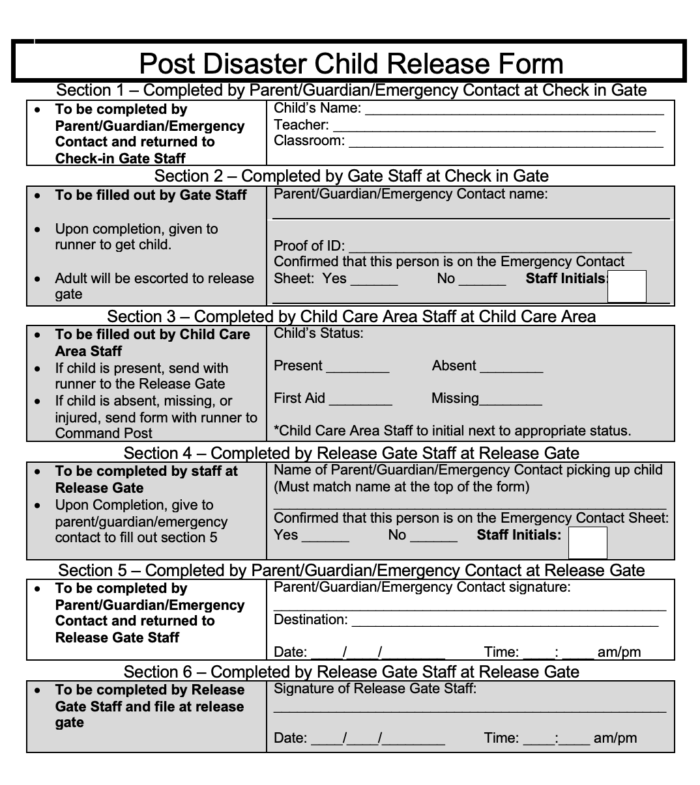

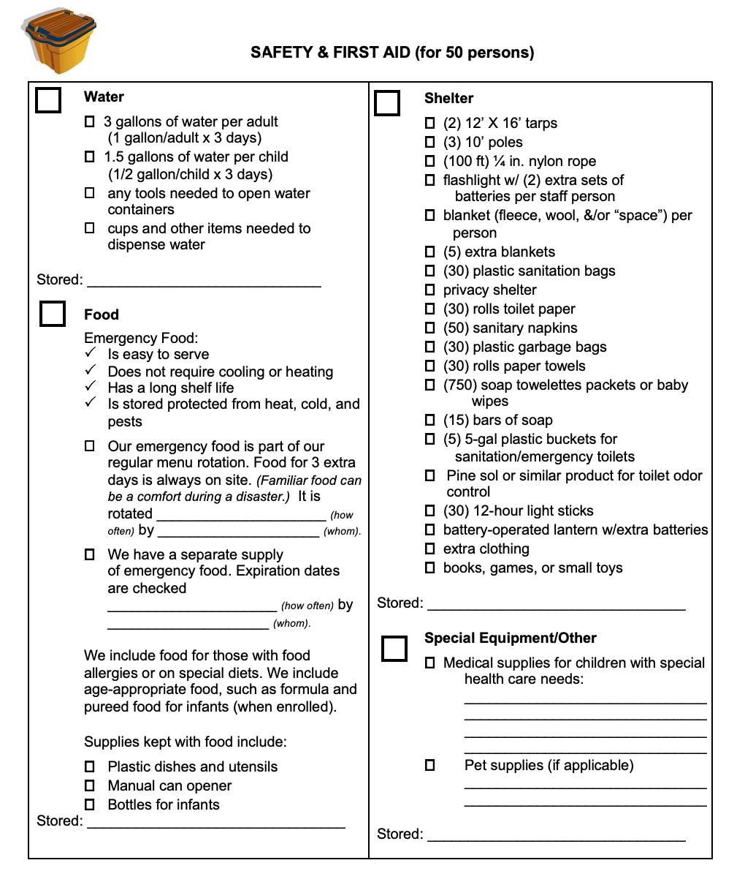

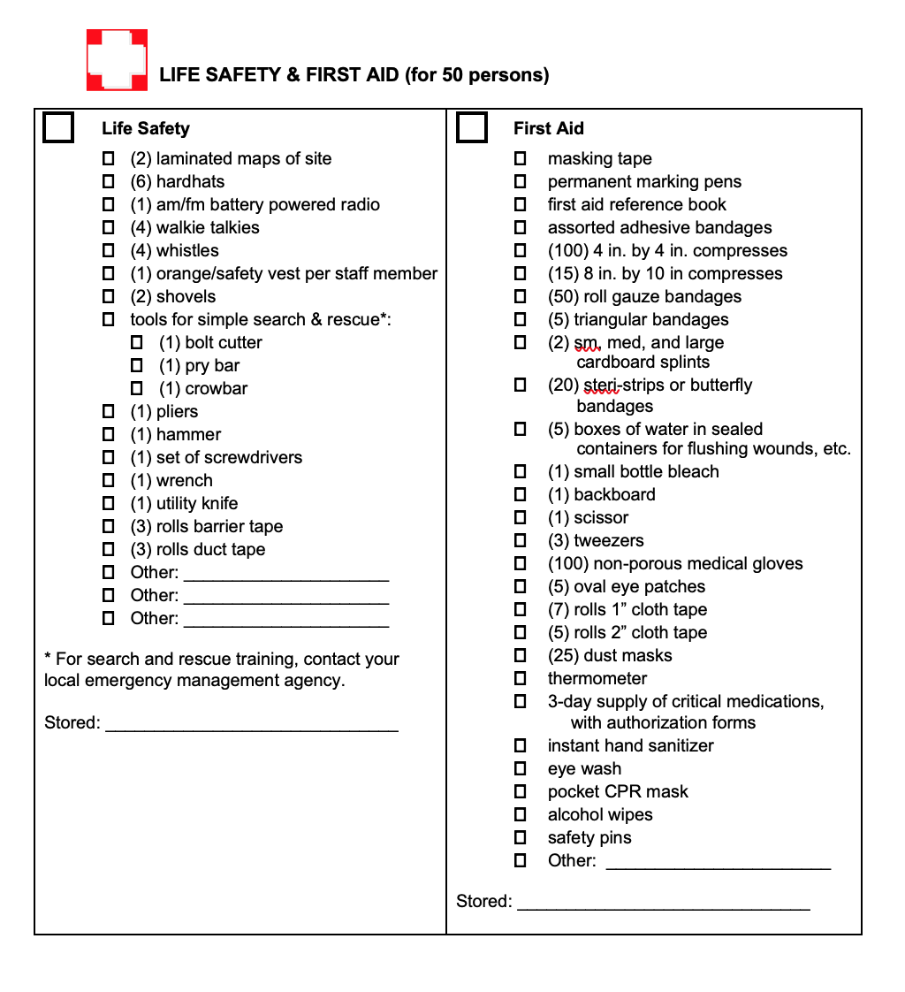

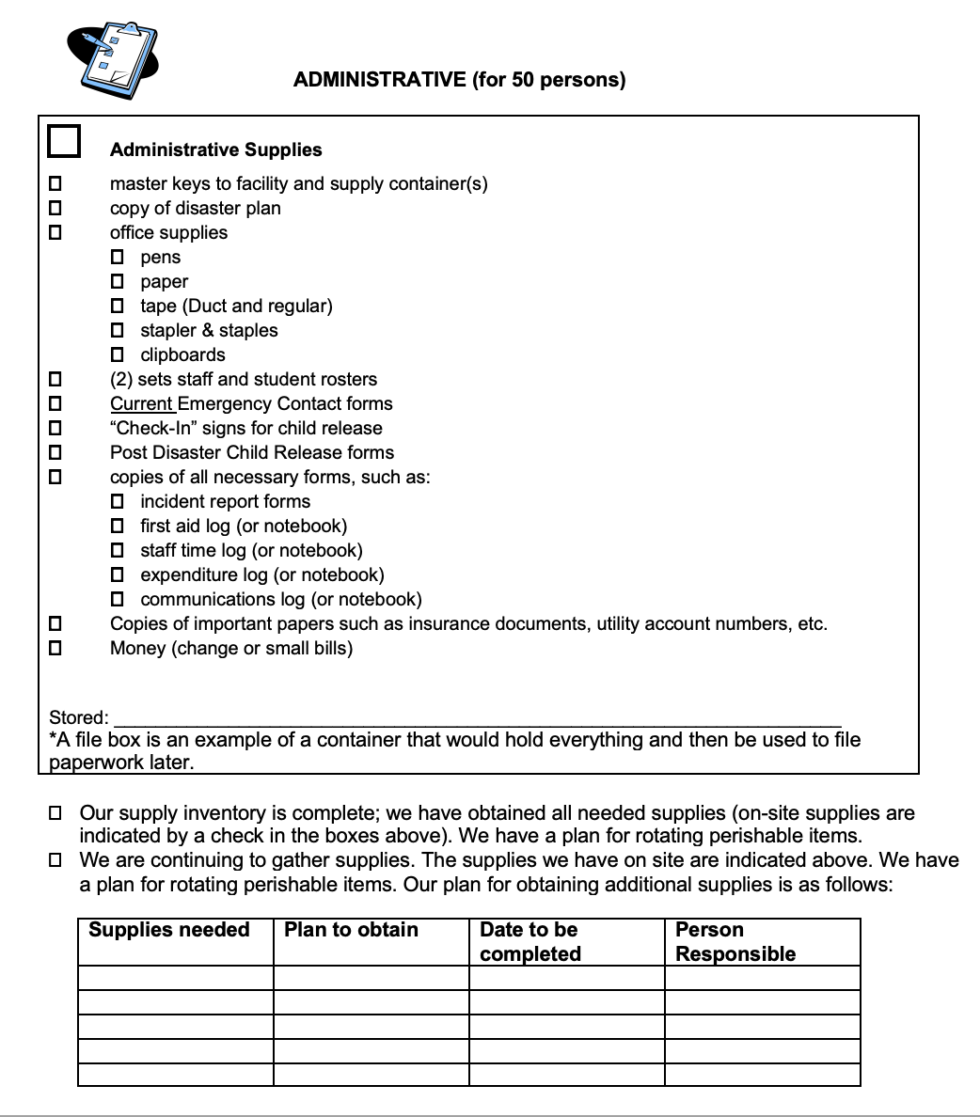

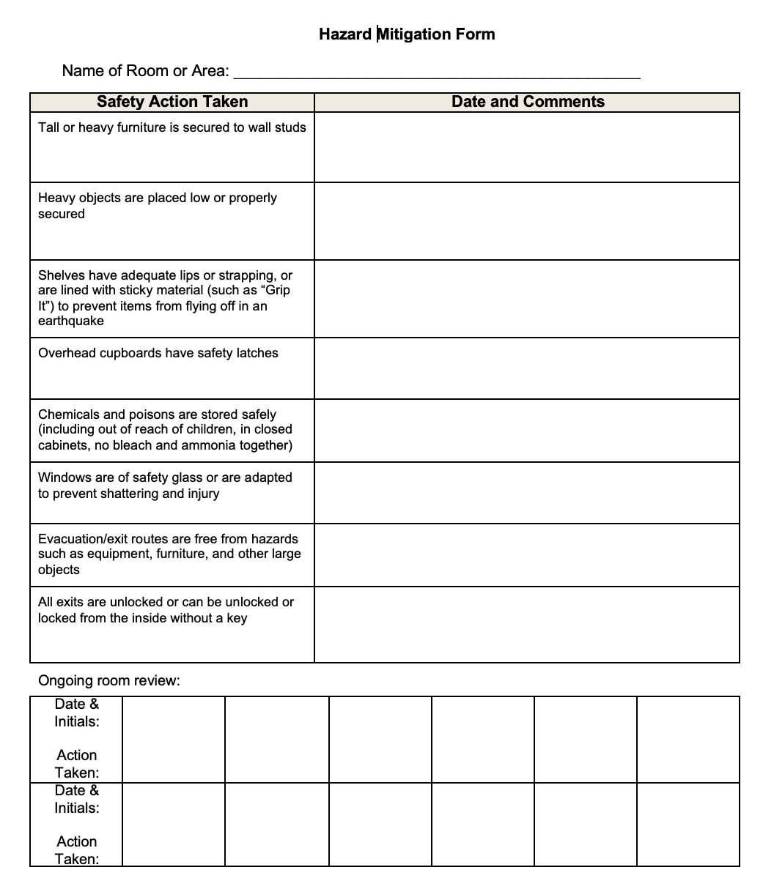

ACKNOWLEDGMENT OF RECIEPT OF PARENT HANDBOOK
Today’s Date:

- I ____________________________have received a copy of the INSERT SCHOOL’S NAME the Emergency Procedures and Risk Management Plan Handbook
- I agree and understand the policies and procedures listed in this handbook and will comply with the school’s rule and regulations.
- I understand that this policies and procedures listed in this handbook are subject to change to reflect the needs of the program.
- I understand I will be made aware of these changes in a timely fashion, and I will always adhere to the most up to handbook.

Employee Signature Date

Terms and Conditions
Copyright © 2021 Halle Rubin. All Rights Reserved.
Except where indicated, this publication (the “Publication”) is owned exclusively by [Halle Rubin] (“Publisher”), including but not limited to text, graphics, charts, photographs, compilations, and the arrangement of such content and is protected by US copyright laws. By purchasing the Publication and/or using the Publication, you agree to the terms contained herein.
You may use this publication solely for your businesses’ own internal use. You may make copies of the Publication and host the Publication on your businesses’ internal network for access by [staff, students, parents]. You may not resell, rent or license the Publication or any portion of the Publication for any other purpose without the prior written permission of the Publisher.

Although the Publisher has taken reasonable steps to verify that the content of this publication is accurate and authoritative, the Publisher does not represent or warrant that this publication will comply with any particular state or federal law or regulation. The publisher makes no representations or warranties with respect to the accuracy or completeness of the contents of this work and specifically disclaims all warranties, including without limitation warranties of fitness for a particular purpose. The content contained herein may not be suitable for every situation.

Neither the publisher nor the author shall be liable for damages arising from your use of the Publication. The fact that state or private organization, or other specific information, is referred to in this Publication as a citation and/or a potential source of further information does not mean that the Publisher endorses the information such organization may provide. Further, readers should be aware that information contained in this publication continually changes and may have changed between when this work was written and when it is read.

